Time : 1.5 hours

1. The mean of the 20 values in a given dataset is 50. When these values are rearranged in a certain order, the mean of the first 10 values and the last 11 values are 40 and 60 respectively. Find the tenth value after the rearrangement. (2)

Ans : 60

1. The sample standard deviation of simple interest on investment A is 0.10 while the

sample standard deviation of simple interest on investment B is 0.05. If the sample

covariance of simple interest on A and B is 0.0030, the correlation coefficient between

the simple interest on A and B is? (2)

Ans : 0.6

1. A letter is selected from the letters of the phrase “MACHINE”. What is the probability

that the letter selected is not a vowel? (2)

Ans : 4/7

1. You toss a fair coin three times:
2. What is the probability of three heads, HHH? (1)
3. What is the probability that you observe exactly one heads? (1)
4. Given that you have observed at least one heads, what is the probability that you observe at least two heads? (2)

Answers :

1. 1/8
2. 3/8
3. 3/8
4. Let A and B be the two events of a random experiment. Probability that at least one

of the two events A and B will occur is 0.6. Probabilities of event A occurring and B

occurring are 0.3 and 0.4 respectively. Find the probability that event A will occur given

that event B has occurred. (2)

Ans : 0.1/0.4

1. Three coins are tossed simultaneously. Let a random variable X be defined as number of heads minus number of tails resulting from the toss of the three coins. What are the values that X can take? (2)

Ans : -3,-1,1,3

1. (3)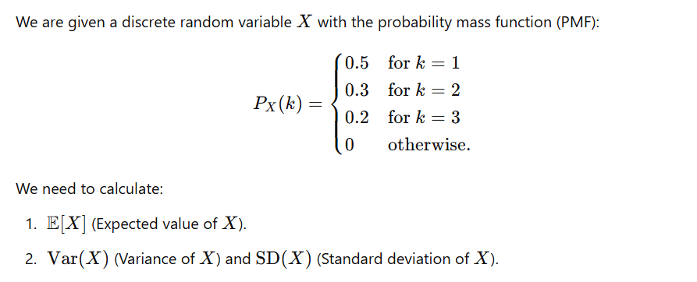

Ans :

1. E(X)=1.7
2. Var(X)=0.61 and SD(X)=0.781

8. A call center receives an average of 5 calls per hour. The number of calls received follows a Poisson distribution. What is the probability that the call center receives exactly 3 calls in an hour? (2)

Ans : 0.14